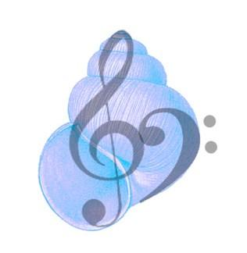
WEYMOUTH AND DORSET MUSIC FESTIVAL 2025

QUESTIONNAIRE AND INITIAL APPLICATION TO TAKE PART

We are planning the next festival which will be held on Saturday March 1st 2025.
It would be very helpful if you could download and complete this form, then email it to us at:
weymouthmusicfestival@live.co.uk

NAME OF SCHOOL/SOCIETY/CHOIR/GROUP/INDIVIDUAL

CONTACT NAME

CONTACT DETAILS (EMAIL)

Have you heard of WDMF previously? Yes
No

Have you taken part before? Yes
No

Are you/your school/choir/band/group interested in taking part? Yes
We will ask for a definite commitment in the Autumn of 2024 No

Do you need more information? Yes
No

We are considering a change of venue.
Which location would you prefer, Weymouth or Dorchester or elsewhere in the county?
WEYMOUTH
DORCHESTER
Elsewhere?

Traditionally the festival has run classes for each genre eg Strings/Woodwind/Brass/Keyboard/Vocal/ Choirs/Bands. Professional adjudicators give constructive feedback on individual performances.
Should there be more or less adjudication? More
Less

If you have decided NOT to take part could you please tell us why ?

Do you have any suggestions or comments?

ALL REPLIES WILL BE TREATED AS CONFIDENTIAL

